**NOTES**

**• home router**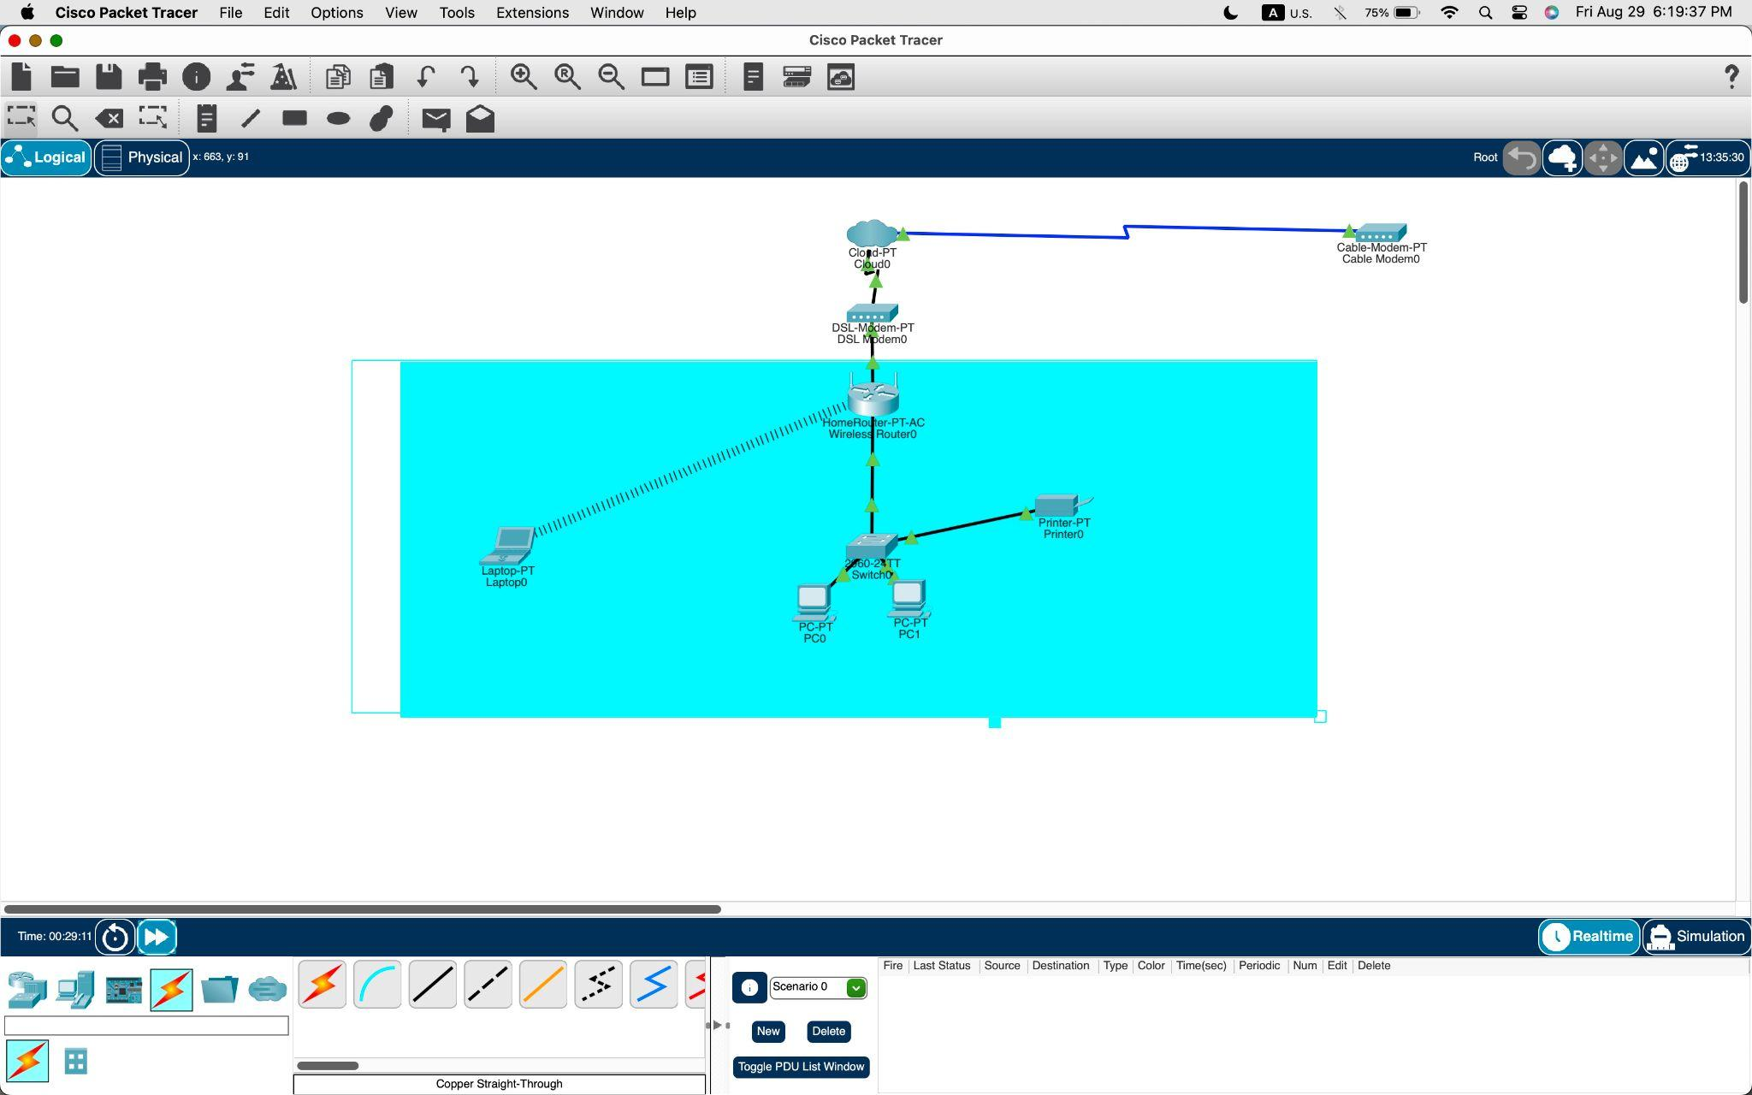

**Notes/ What was used.**

**Cisco switch**

**Two PCs**

**Laptop**

**Printer**

**DSL modem**

**Packet tracer cloud or internet box**

**Structure a basic network**

**Configure end devices like a home router, PC, laptop, and printed change interfaces on computers**

**Configure basic routers**

**Navigate the GUI**